**DID Read**

What I request is Tx in CANoe

What I get as response is Rx in CANoe

Created R port in appldiag and read a dummy value from p port of proxy (dcdcinputpower interface)

In proxy the value written in p port is changed using a dummy variable and giving that dummy as input to function in Rte write p port function(dummy)

This dummy value is got into connected R port of appldiag to the runnable Fingerprint read which is a runnable related to DCM. The appldiag is having some runnable that is related to DCM. The appldiag swc act as server and DCM act as client. This connection is already established so when we give the value from p port of proxy to r port of appldiag, we can read this dummy value in diagnostic console using the DID number.

We can also make the Read Function created in appldiag to read any value whether from any port or any constants defined in the application

22 F010 is the DID of fingerprint read

22 is Service identifier used to Read Data by identifier

And F010 is the DID

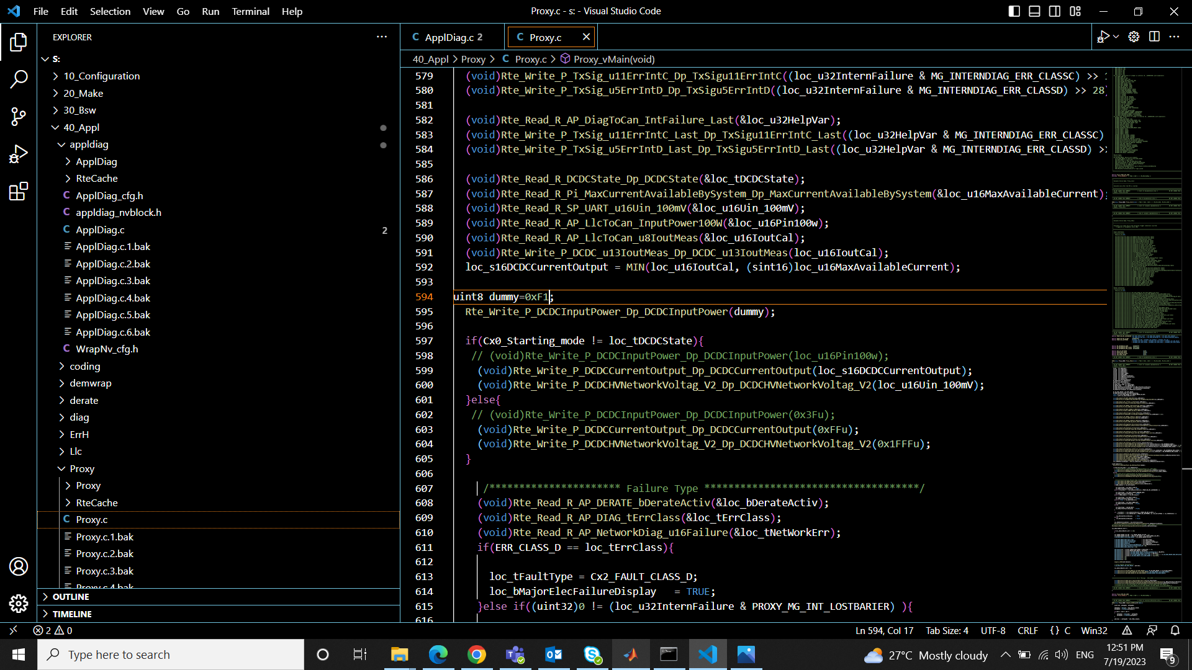

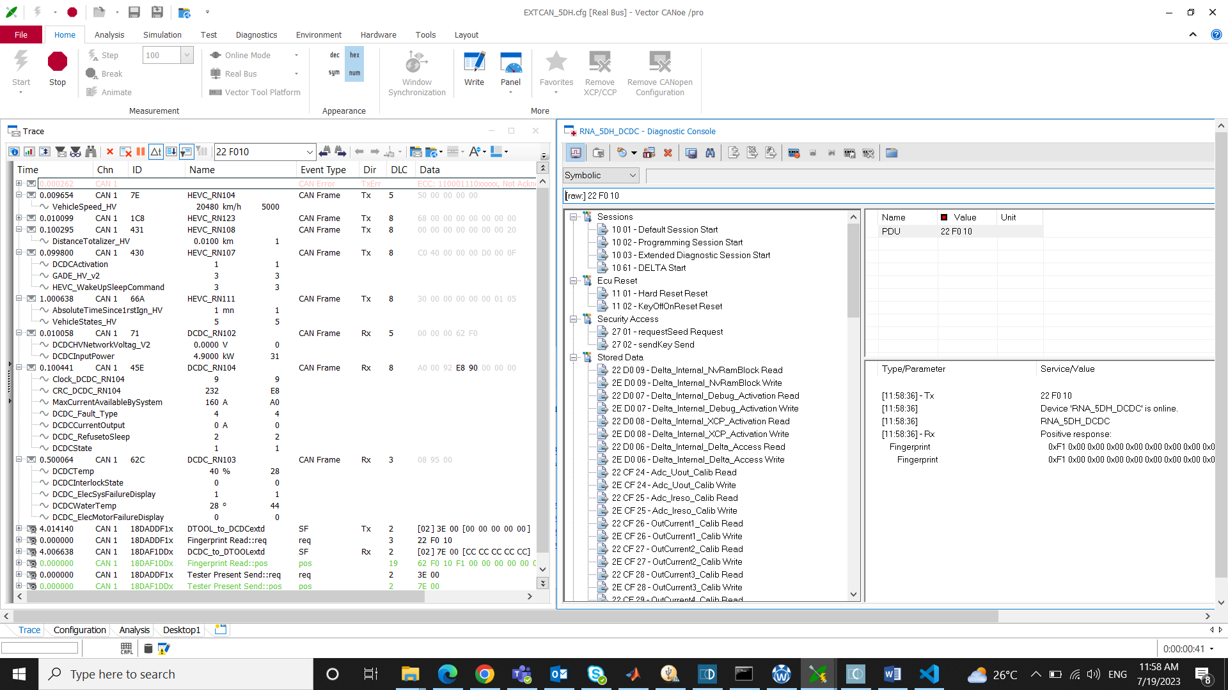

3)

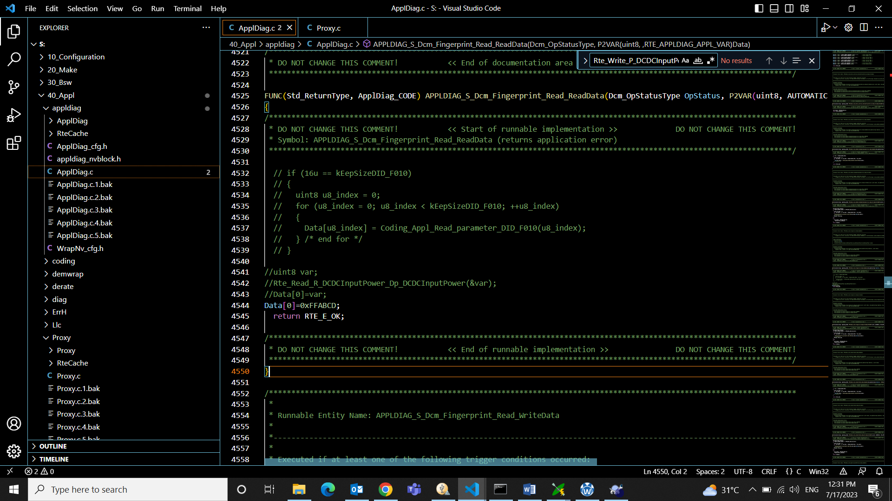

**UDS - IS0-14229 Protocol**

**NRC-** used to identify the internal protocol fault for not following the standard.

When accessing DID that are out of the session scope or due to any reason, the ECU sends NRC which can be looked up to see what caused that negative response.

Read about NRC table from [web](https://piembsystech.com/negative-response-codes-nrc-uds-protocol/?expand_article=1).